

**LAB FILE**

**Web Programming with Python and JavaScript Lab**

**(SEC 035)**

**SUBMITTED BY:**

**ADEELA AZEEZ**

**SUBMIITED TO:**

**DR. TANVI CHAWLA**

**ROLL NUMBER: 2301010282**

**COURSE: BTECH CSE CORE**

**SECTION: E**

**School of Engineering & Technology**

**K. R. MANGALAM UNIVERSITY**

**Sohna, Haryana 122103, India**

**EXPERIMENT 11**

**Basic Flask Programs**

***Experiment 11.1: Basic "Hello, World!" Flask App***

**Code:**

from flask import Flask

app = Flask(__name__)@app.route('/')

def hello_world():

return "Hello, World! Welcome to Flask."

if __name__ == '__main__':

app.run(debug=True)

**Output:**

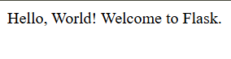

***Experiment 11.2: Flask App with Dynamic Routes***

**Code:**

from flask import Flask

app = Flask(__name__)

@app.route('/user/<username>')

def show_user_profile(username):

return f"Hello, {username}! Welcome to your profile."

@app.route('/square/<int:number>')

def square_number(number):

return f"The square of {number} is {number**2}"

if __name__ == '__main__':

app.run(debug=True)

**Output:**



***Experiment 11.3: Flask App with HTML Templates (Jinja2)***

**Code:**

**HTML Template (templates/home.html):**

<!DOCTYPE html>

<html lang="en">

<head>

<title>{{ title }}</title>

</head>

<body>

<h1>Welcome to {{ title }}!</h1>

<p>This is a dynamic page rendered using Flask and Jinja2.</p>

</body>

</html>

**Python Code (app.py):**

from flask import Flask, render_template

app = Flask(__name__)

@app.route('/')

def home():

return render_template('home.html', title="Flask Template Example")

if __name__ == '__main__':

app.run(debug=True)

**Output:**

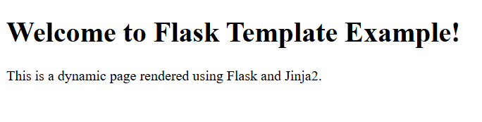

***Experiment 11.4: Flask App with Forms***

**Code:**

**HTML Form (templates/form.html):**

<!DOCTYPE html>

<html lang="en">

<head>

<title>Flask Form Example</title>

</head>

<body>

<h2>Enter your name:</h2>

<form action="/greet" method="post">

<input type="text" name="name" required>

<input type="submit" value="Submit">

</form>

</body>

</html>

**Python Code (app.py):**

from flask import Flask, request, render_template

app = Flask(__name__)

@app.route('/')

def form():

return render_template('form.html')

@app.route('/greet', methods=['POST'])

def greet():

name = request.form['name']

return f"Hello, {name}! Welcome to Flask."

if __name__ == '__main__':

app.run(debug=True)

**Output:**

